26.7 Editors - Properties Editor - Object Properties Tab
Object Tab 3
Object Data Prop 3
Object browser 3
File selector menu 3
Transform Panel 4
Location 4
Rotation 4
Rotation Mode 4
Quaternion 4
Scale 4
Lock 4
Animate Properties 5
Delta Transform 5
Delta Location 5
Delta Rotation 5
Delta Scale 5
Lock 5
Animate Properties 5
Relations Panel 5
Animate Properties 5
Parent 5
Parent Type 6
Parent Bone 6
Camera Parent Lock 6
Tracking Axis 6
Up Axis 6
Pass Index 6
Collections Panel 6
Add to collection 6
Add Collection 6
Collection 6
Collection Name 7
Remove 7
Collections Menu 7
Offset 7
Instancing Panel 7
None 8
Instanceverts 8
Workflow: 8
Instanceverts Tools 9
Animate Property 9
Align to Vertex Normal 9
Show Instancer 9
Dupliface 9
Workflow: 9
Instance Face Tools 10
Animate Property 10
Show Instancer 10
Scale by Face Size 10
Factor 10
Motion Paths Panel 10
Workflow: 11
Motion Paths Tools: 11
Paths Type 11
Cache From and To 12
Update Paths 12
Delete Paths 12
Display 12
Visibility Panel 12
Animate property 13
Show In 13
Viewports 13
Renders 13
Grease Pencil 13
Use Lights 13
Viewport Display Panel 13
Animate property 13
Show 13
Name 13
Axis 14
Wireframe 14
All Edges 14
Texture Space 14
Shadow 14
In Front 14
Color 15
Display As 15
Bounds 15
Custom Properties Panel 15
Add 15
Edit 15
Remove 15

Object Tab

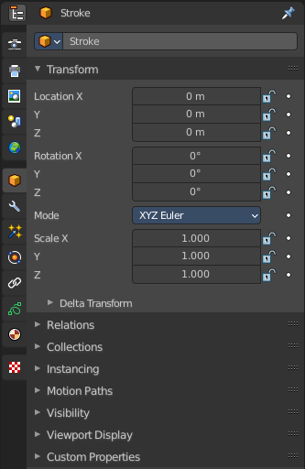
The Object tab contains all general object related settings like Transform, Relation or Collection related things. It is the same for all object types and in all modes.

Object Data Prop
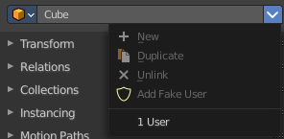
Displays what object is currently selected.

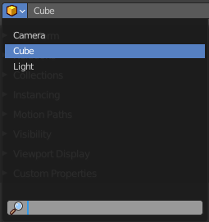
Object browser
A list of the objects in the scene. In this list you can also choose another object. And you can rename the object.

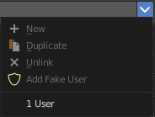
File selector menu
This menu has no meaning in this context. All menu items are disabled.

Transform Panel
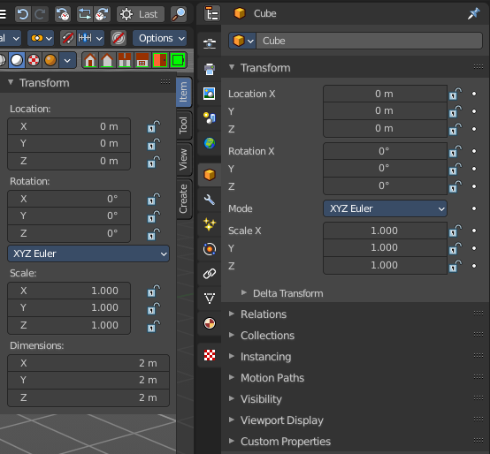
Transform is position, rotation and scale of the object. It is partially the same content that you see in Object mode in the Properties sidebar in the 3D view.

However, when you switch to Edit mode, with a Bone for example, then you will still have the overall world transform values for the object here, while the Transform panel in the Properties sidebar now displays the edit transform values for the bone.

Location
The location of the object.

Rotation
The rotation of the object.

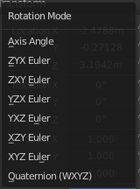
Rotation Mode
The rotation mode. Euler angles are fine for most needs. But sometimes you want to use Quaternion to avoid gimbal lock. Gimbal lock is a mathematical problem where the rotation locks up in two instead of three degrees of freedom.

Quaternion
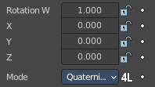
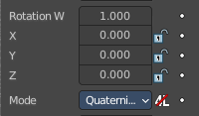
With euler angles you will have three values available. But with a quaternion you will have four values available. And quaternions reveals a 4L button. This button shows or hides a lock behind the W value. Normally a quaternion has just three locks, one for each of the single axis. The W value is a mathematical construct from the three object axis. And you usually neither want to edit it nor to lock it therefore.
Locking the W axis will lock all axis.

Scale
The scale of the object.

Lock
This properties can be locked.

Animate Properties
This properties can be animated. Activating the Animate Property button sets a keyframe.

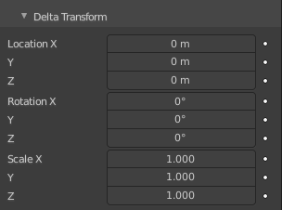
Delta Transform
Transforms are absolute to the world coordinates. Delta Transforms are relative to the current transformation.
Adjust the delta transforms.

Delta Location
The delta location of the object.

Delta Rotation
The delta rotation of the object.

Delta Scale
The delta scale of the object.

Lock
This properties can be locked.

Animate Properties
This properties can be animated. Activating the Animate Property button sets a keyframe.

Relations Panel

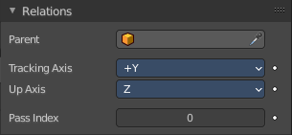
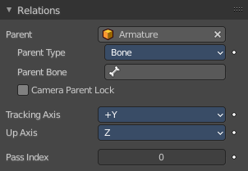
Set up and adjust relations for the object.

Animate Properties
The properties with the Animate Property at the right can be animated. Activating the Animate Property button sets a keyframe.

Parent
Set a parent object. One way is by the object picker at the right. Or choose the object in the list. This list appears by clicking at the edit box.

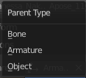
Parent Type
See and set the parent type.

Parent Bone
When you parent an object to an armature then you can choose to which bone you want to parent this object.

Camera Parent Lock
When the camera is locked to the view and in fly mode, transform the parent rather than the camera.

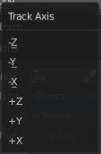
Tracking Axis
The axis that points in forward direction.

Up Axis
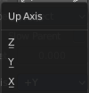
The axis that points in the up direction.

Pass Index
The index number for the "Object Index" render pass.

Collections Panel
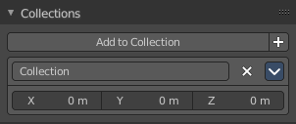
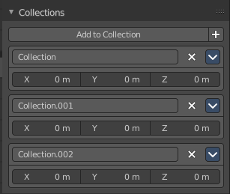
Collections is a bunch of data, objects, cameras, lights, etc., which you can manage in some ways at once. You can for example hide complete collections, include or exclude it from rendering, instance them, and so on.

An object must be at least in one collection. Or it gets deleted. But an object can be in multiple collections. This panel allows you to manage in what collection(s) the object is.

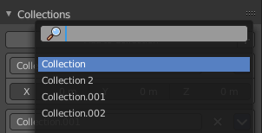
Add to collection
A drop down box where you can choose the collection that you want to add the object to.

Add Collection
At the end of the Add to Collection element is a + button where you can add more collections.

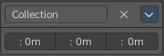
Collection
This is the collection where the object is currently assigned at. As told, an object can be assigned to more than one collection.

Collection Name
Read and edit the collection name.

Remove
This deletes the collection from the object. Note that the collection still exists.

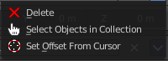
Collections Menu

Delete
This deletes the collection from the object. Note that the collection still exists.

Select Objects in Collection
Selects all objects in the collection.

Set Offset From Cursor
Set offset used for collection instance based on cursor position. Normally the offset is based at the center of the world when instancing, at 0/0/0. When you choose Set Offset From Cursor then this offset is set form the cursor position instead of the world center.

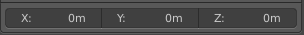
Offset
Offset from the origin to use when instancing.

Instancing Panel

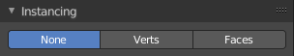
Here you find settings for instancing. Instancing means the object exists just one time in ram, and gets reused.

Instancing requires a special setup.

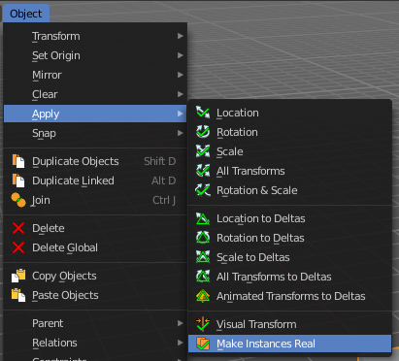
The duplicated geometry by this method are instances of the parent object. And so they cannot be threaten like real objects.

To turn them into editable geometry go to Object menu, and choose Apply / Make Duplicates real.

None
No duplication happens.

Instanceverts
InstanceVerts is the duplication of a base object at the location of the vertices of a mesh. In other words, an instance of the base object is placed on every vertex of the mesh.

Workflow:
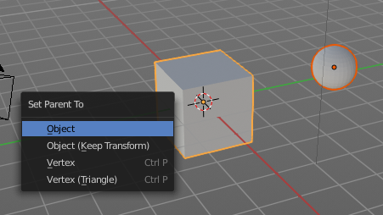
Create a cube, create a sphere. For demonstration purposes, move the sphere a bit off. Parent the sphere to the cube. Cube must be the parent, sphere the child.

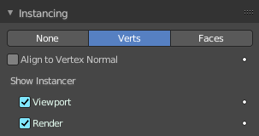
Select just the cube. In the Duplication Panel enable Verts.

As a result you will now have eight spheres around the child sphere, since the cube has eight vertices. The center point is the sphere.
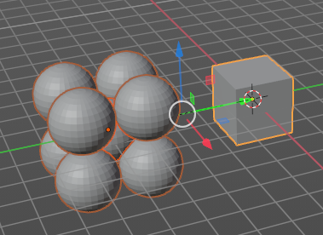

Instanceverts Tools

Animate Property
The properties with the Animate property at the right can be animated. You create a keyframe by clicking at it.

Align to Vertex Normal
Orients the child objects along the normals of the parent vertices.

Show Instancer

Viewport
Show the instance object in the viewport.

Render
Show the instance object in the final rendering.

Dupliface
DupliFaces replicates an object on each face of a parent object, using the initial child object as the center. The faces of the parent object is the pattern that gets used as the pattern to create the duplicated objects. The child object gets used as the center point, and of course to duplicate the geometry from.

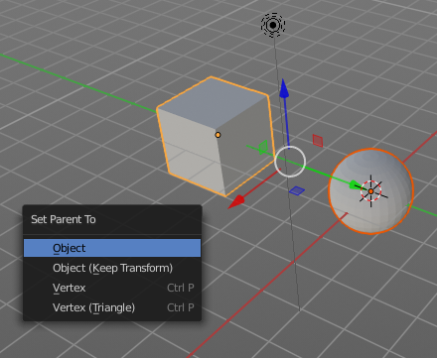
Workflow:
Create a cube, create a sphere. Move the cube a bit off. Parent the sphere to the cube ( select sphere, hold down shift, select cube, press ctrl p). Cube must be the parent, sphere the child.

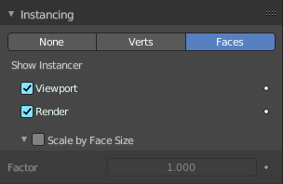
In the Duplication Panel enable Faces.

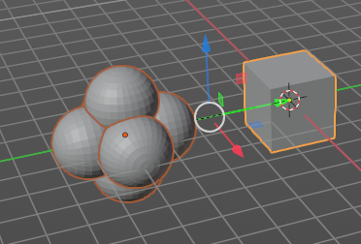
As a result you will now have six spheres at the child sphere, since the cube has six sides.

Note
The location, orientation, and scale of the duplicated child(ren) matches that of the faces of the parent. So, if several objects are parented to the cube, they will all be duplicated once for each face on the cube. If the cube is subdivided, every child will be duplicated for each face on the cube.

Instance Face Tools

Animate Property
The properties with the Animate property at the right can be animated. You create a keyframe by clicking at it.

Show Instancer

Viewport
Show the instance object in the viewport.

Render
Show the instance object in the final rendering.

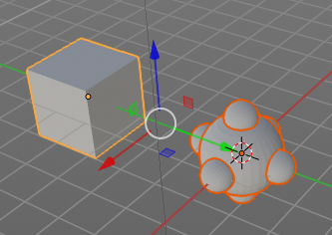
Scale by Face Size
When you tick scale by face size then you can control the size of the child objects.

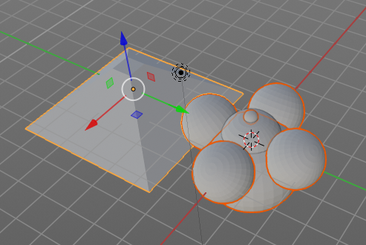
With Scale ticked you can also influence the size of the child objects by changing the parent geometry.

Factor
The scale factor for scale.

Motion Paths Panel
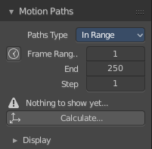
Motion paths is a visual helper to judge the motion of objects.

Motion paths are not displayed by default. They need to be calculated. This can be done here.

Workflow:
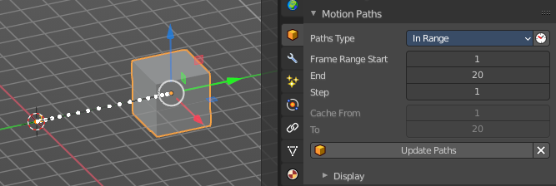
We simply need a motion animation first. For example a moving cube.

Add a cube. Choose a keying set. Set a keyframe at let's say frame 0. Go to frame 20. Move the object. Set a keyframe at frame 20.

Click Calculate. You will now see the motion path of this object.

Motion Paths Tools:

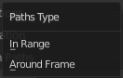
Paths Type
There are two path types available. In Range and Around Frame.

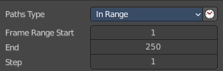
In Range
Displays the full motion path.

Paths range update
Update Frame Range for Motion paths from the scene's current frame range.

Frame Range Start
The start frame.

End
The end frame.

Step
Number of frames between paths shown.

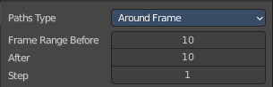
Around Frame
Displays just the motion path around the current frame. Not the whole path.

Frame Range before
The frames to display before the current frame.

After
The frames to display after the current frame.

Step
Number of frames between paths shown.

Cache From and To
Not editable. Internal cache information that should be hidden.

Update Paths
Update the paths after any changes at the animation. You have to update the paths too if you change settings like the paths type.

Delete Paths
Deletes ALL motion paths caches in the scene. Hold down shift to delete just the path for the current object.

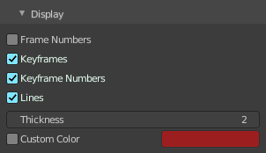
Display
Here you find some display options for the path.

Frame Numbers
Display the frame number above every knot of the motion path

Keyframes
Display the keyframes in the path as orange dots.

Keyframe Numbers
Display the keyframe number above every keyframe.

Lines
Display a line between the points.

Thickness
The line thickness.

Custom Color
Define a custom color for the motion path. A click at the color area opens a color picker.

Visibility Panel

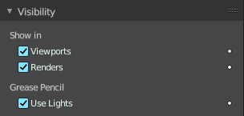
Animate property
These property can be animated. Clicking at the decorator at the right sets a keyframe.

Show In

Viewports
Show the object in the viewport. This can also be done in the outliner.

Renders
Show the object in the rendering. This can also be done in the outliner.

Grease Pencil

Use Lights
Grease Pencil object only. Light affects grease pencil object.

Viewport Display Panel
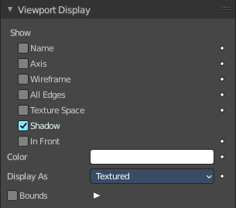
Here you will find some further display options for the object. Object name, Wire Frame in Object Mode, etc.

Some of these settings will override general settings. For example when you set the maximum draw type (Display as) to Wire, then it will always display as wire, regardless if you set the Viewport render method to Material or Textured.

The content is different for different object types. Mesh objects have more options than a grease pencil for example.

Note also that some objects have some further special viewport settings in other tabs. For example, Bones have also viewport settings in the Object Data properties, and in the Bone properties.

This panel here is for general viewport display settings for the objects.

Animate property
These properties can be animated. Clicking at the decorator at the right sets a keyframe.

Show

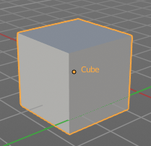
Name
Display the object name at the pivot point.

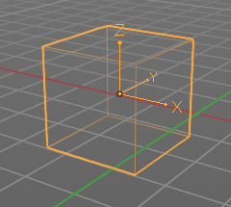
Axis
Display the objects axis. Best done with Wireframe display mode. Solid faces may hide the axis. Or tick in Front. Then the axis gets also drawn above the mesh faces.

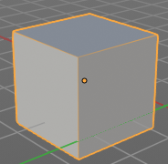
Wireframe
Display parts of the wire frame in Object Mode. See All Edges.

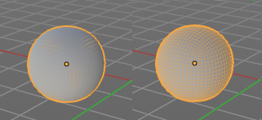
All Edges
This is a hieronymus bosch feature from Blender developers that will most probably trap you again and again. When you tick Wireframe then SOME of the edges of the object gets displayed. You need to tick all edges to display the whole Wireframe.

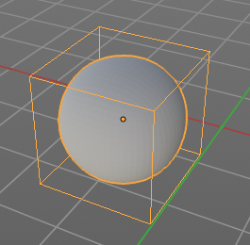
Texture Space
Display the objects texture space. This has to do with the mapping. A sphere can for example have a cubic mapping.

Shadow
The object should throw a shadow in the 3D view. But it seems to be dysfunctional.

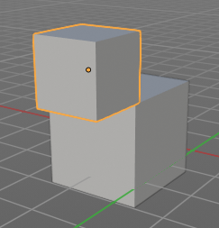
In Front
X Ray. Display this object in front of all other objects.

Color
Object Color and Alpha that is used when Faces have the ObColor Mode enabled.
No idea where that gets enabled. Thanks Blender Devs!

Display As
Adjust the maximum display method for the object. For example when you set the maximum draw type to Wire, then it will always display as wire, regardless if you set the Viewport render method to Material or Textured.

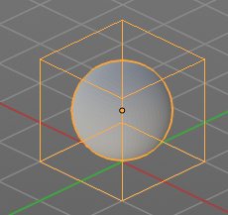

Bounds
Display the bounding box for this object.

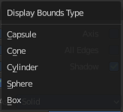
Display Bounds Type
What shape to choose for the bounding box. There is more than just the classical box shape available.

Custom Properties Panel


Define custom properties that can be used for scripting.

Here you might also find custom properties from addons or scripts.

Add
Adds a new property.


Edit
A panel to adjust the settings for the custom property.

Remove
Removes the property.

